**Table Of Content:**

1. Introduction
2. Title and Internal Titles
3. Technologies
4. Scope of Functionality
5. Launch/Setup
6. Screenshot
7. Usage
8. Project Status
9. Room for Improvement
10. Acknowledgement
11. Contact
12. **What Problem does this project solve?**

The Mzamomtsha Primary School Project is for developing an online presence for the school by building a website that attracts stakeholders such as Parents and Sponsors to keep them informed about the school as well as promote the schools desire to expand and accommodate new learners and staff.

1. **Title and Internal Titles**

The title one the website are for the pages on it, these include; Home Page(where you navigate through slideshows and enrolling), About page (where you learn more about the school), Events Page (where you find sports day, SGB meetings and donations), Contact Page (where you get a form on how to contact the school), and the FAQs Page (where you find Frequently Asked Questions by stakeholders).

1. **Technologies**

* Bootstrap 3 or 4
* Html
* Css
* JavaScript

1. **Scope of Functionality**

* Features:
  + Enrol
  + Login/Sign up.
  + Enquire
  + Search
  + Navigate/Explore
* To do:
  + When you enrol, you will fill out a form about personal information of the parent and pupil.
  + When approved/accepted, learner/staff will signup and login to the schools LMS.
  + You can send queries to the admin about more specify details that aren’t on the website.
  + You can search for content that’s on the website from any page.
  + You can explore all the content on the website, from events to slideshows as well as achievement of the school.

1. **Launch/SETUP:**

The website will be launched on NETLIFY.

1. **Screenshot:**

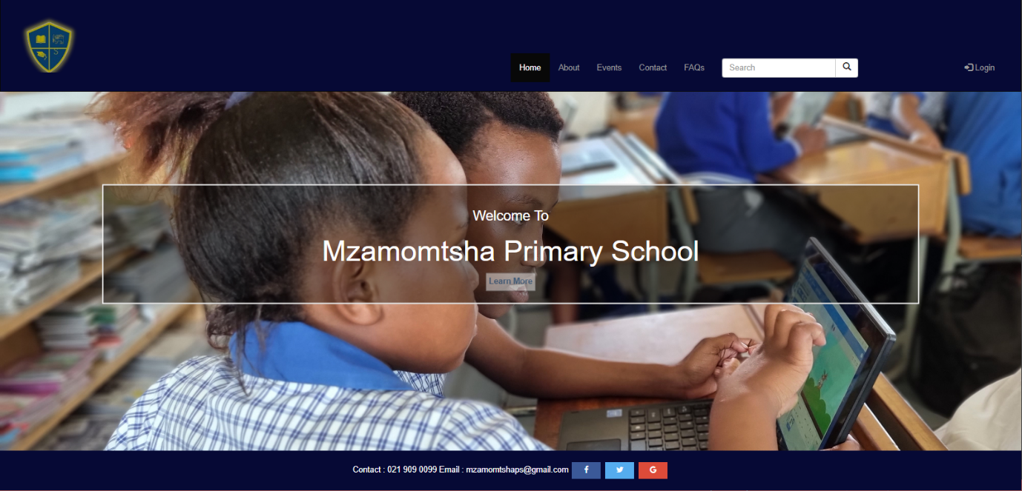

1. **Usage:**

In the code below, this is the code used to create the Navigation Bar that allows users to navigate the pages of the website as well as include the login button for staff, teachers and learners.

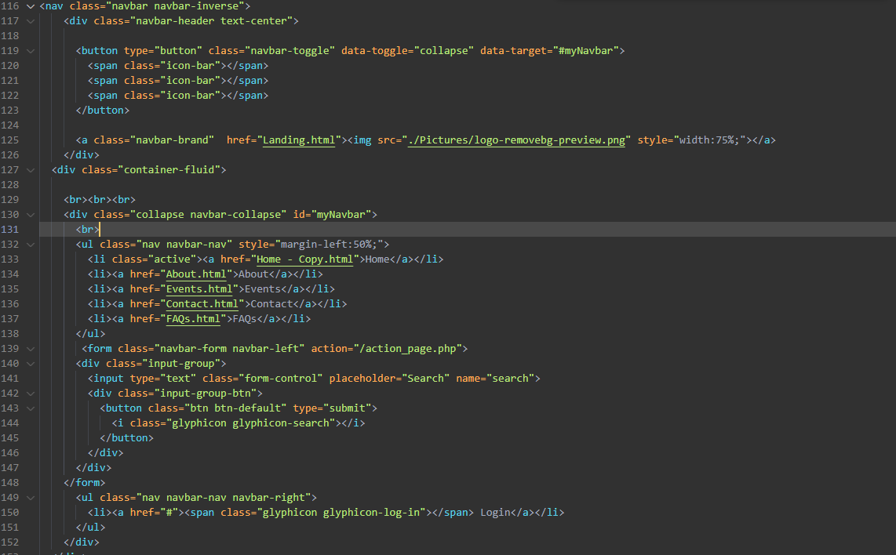

1. **Project Status:**

The project is still in progress and is being continuously being updated.

1. **Room For Improvement:**

* Features:
  + Styling
  + Pages
* To Do:
  + Styling for the content requires improvement.
  + Additional pages for signup options for new learners, admin and staff.

1. **Acknowledgement:**

The source for many source codes was found on the CapaCiTi LMS <https://www.classes.capaciti.org.za> on the guideline and <https://www.w3schools> for stylesheets and coding languages used.

1. **Contact:**

Created by **Creative Devs** – contact us any time.

[Mamnkeli.Khaka@capaciti.org.za](mailto:Mamnkeli.Khaka@capaciti.org.za)

[Boitumelo.Mokobane@capaciti.org.za](mailto:Boitumelo.Mokobane@capaciti.org.za)

[Sonwabile.Zamliza@capaciti.org.za](mailto:Sonwabile.Zamliza@capaciti.org.za)

[Luyanda.Sopazi@capaciti.org.za](mailto:Luyanda.Sopazi@capaciti.org.za)

[Potego.Mahwibila@capaciti.org.za](mailto:Potego.Mahwibila@capaciti.org.za)